VILNIUS UNIVERSITY

Artūras Samuilis

ANATOMICAL VARIANTS OF THE HEPATIC ARTERIES AND THEIR INFLUENCE ON SUPERIOR MESENTERIC ARTERY HEMODYNAMICS

Summary of doctoral dissertation
Biomedical sciences, Medicine (07B)

Vilnius, 2011

Doctoral thesis was performed at Vilnius University in 2006 – 2010

Scientific supervisor:
Ph. D., Professor Algirdas Edvardas Tamošiūnas (Vilnius University, biomedical sciences, medicine – 07B)

Scientific consultant:
D. Sc., Professor Kęstutis Strupas (Vilnius University, biomedical sciences, medicine – 07B)

Doctoral thesis will be defended at the Scientific Council of Medical Sciences of Vilnius University:

Chairman:
Ph. D., Professor Edvardas Danila (Vilnius University, biomedical sciences, medicine – 07B)

Members:
Ph. D., Professor Algidas Basevičius (Lithuanian University of Health Sciences, biomedical sciences, medicine – 07B)
Ph. D., Professor Virgilijus Beiša (Vilnius University, biomedical sciences, medicine – 07B)
Ph. D., Assoc. Professor Saulius Lukoševičius (Lithuanian University of Health Sciences, biomedical sciences, medicine – 07B)
Ph. D., Assoc. Professor Nomeda Rima Valevičienė (Vilnius University, biomedical sciences, medicine – 07B)

Opponents:
D. Sc., Professor Limas Kupčinskas (Lithuanian University of Health Sciences, biomedical sciences, medicine – 07B)
Ph. D., Professor Janina Tutkuvienė (Vilnius University, biomedical sciences, medicine – 07B)

The public defence of doctoral thesis will be held at the open meeting of the Scientific
Council of Medical Sciences on April 28, 2011, at 2.00 PM in the conference hall of
Vilnius University Hospital Santariškių klinikos.
Address: Santariškių str.2, Vilnius, LT- 08661, Lithuania

The summary of the doctoral thesis was sent on March ____, 2011
The doctoral thesis is available in the Library of Vilnius University.
Address: Universiteto str.3, LT-01122, Vilnius, Lithuania

VILNIAUS UNIVERSITETAS

Artūras Samuilis

KEPENŲ ARTERIJŲ ANATOMINIAI VARIANTAI IR JŲ ĮTAKA VIRŠUTINĖS PASAITO ARTERIJOS HEMODINAMIKAI

Daktaro disertacijos santrauka
Biomedicinos mokslai, medicina 07B

Vilnius, 2011
Disertacija rengta 2006 – 2010 metais Vilniaus universitete

Mokslinis vadovas:
Prof. dr. Algirdas Edvardas Tamošiūnas (Vilniaus universitetas, biomedicinos mokslai, medicina –07B)

Mokslinis konsultantas:

Prof. habil. dr. Kęstutis Strupas (Vilniaus universitetas, biomedicinos mokslai, medicina –07B)

Disertacija ginama Vilniaus universiteto Medicinos mokslo krypties taryboje:

Pirmininkas:
Prof. dr. Edvardas Danila (Vilniaus universitetas, biomedicinos mokslai, medicina – 07B)

Nariai:
Prof. dr. Algidas Basevičius (Lietuvos sveikatos mokslų universitetas, biomedicinos mokslai, medicina – 07B)
Prof. dr. Virgilijus Beiša (Vilniaus universitetas, biomedicinos mokslai, medicina – 07B)
Doc. dr. Saulius Lukoševičius (Lietuvos sveikatos mokslų universitetas, biomedicinos mokslai, medicina – 07B)
Doc. dr. Nomeda Rima Valevičienė (Vilniaus universitetas, biomedicinos mokslai, medicina – 07B)

Oponentai:
Prof. habil. dr. Limas Kupčinskas (Lietuvos sveikatos mokslų universitetas, biomedicinos mokslai, medicina – 07B)
Prof. dr. Janina Tutkuvienė (Vilniaus universitetas, biomedicinos mokslai, medicina – 07B)

Disertacija bus ginama viešame Medicinos mokslo krypties tarybos posėdyje 2011 m.
balandžio mėn. 28 d. 14 val. Vilniaus universiteto ligoninių Santariškių klinikų
auditorijoje.
Adresas: Santariškių 2, Vilnius, LT- 08661, Lietuva.
Disertacijos santrauka išsiųsta 2011 m. kovo ____ d.
Su disertacija galima susipažinti Vilniaus universiteto bibliotekoje.
Adresas: Universiteto 3, LT-01122, Vilnius, Lietuva

ABBREVIATIONS
CA | celiac artery
CHA | common hepatic artery
CTA | computed tomography angiography
DUS | doppler ultrasound
GDA | gastroduodenal artery
LGA | left gastric artery
LHA | left hepatic artery
PHA | proper hepatic artery
rCHA | replaced common hepatic artery
RHA | right hepatic artery
RI | resistive index
rRHA | replaced right hepatic artery
SA | splenic artery
SD | standard deviation
SMA | superior mesenteric artery
VR | volume rendering

INTRODUCTION

Relevance of the study
A classic pattern of the celiac artery (CA) and hepatic arteries’ anatomy is reported in 75 – 90% and 50 – 81% of cases respectively. The CA is the first major branch of the abdominal aorta and gives origin to the left gastric artery (LGA), splenic artery (SA), and the common hepatic artery (CHA). The CHA bifurcates into the gastroduodenal artery (GDA) and proper hepatic artery (PHA). The PHA bifurcates into the right (RHA) and left hepatic arteries (LHA). Superior mesenteric artery (SMA) is second major branch of abdominal aorta and originates approximately 10 mm below the CA.
Atypically branching hepatic arteries are called aberrant arteries. Aberrant hepatic arteries can be classified as either accessory (occurring in addition to the normal arterial supply) or replaced (representing the primary arterial supply to the liver lobe that does not arise from the CA).
The most common origins of aberrant hepatic arteries are SMA and LGA: 8-27% and 4 – 34% of cases respectively.
The anatomy of celiac and hepatic arteries takes great importance in hepatobiliary, gastric, and pancreatoduodenal surgery, as well as in interventional procedures such as transarterial chemoembolization or infusion chemotherapy of hepatic tumors. Vascular anatomical variants can be determined at the time of surgical exploration. However, it may be difficult to visualize arterial anatomy, especially in patients with large amounts of lymphatic and fatty tissue in the hepatoduodenal ligament, those with tumors that infiltrate the porta hepatis, those who had portal inflammation or previous surgery. In these patients, preoperative radiological imaging of the arterial anatomy is particularly useful and can help to avoid possible surgical complications (hepatic ischemia, hepatic failure, biliary stricture, biliary leak, hemorrhage). Incorrect evaluation of vascular anatomy before infusion chemotherapy or chemoembolization sometimes leads to an inadequate drug distribution in the liver, intestinal complications, or catheter-related arterial occlusion resulting in treatment failure.
The success of liver transplantation, especially living donor liver transplantation, depends not only on vascular anatomy, but also on hepatic arterial diameter, which could be evaluated before surgery using radiological imaging. If the size of these vessels is less than 3 mm in diameter, the patients are at increased risk of thrombosis after transplantation. To decrease the risk, surgeons should change operative tactics (microsurgical techniques, aortohepatic interposition grafts).
The inferior phrenic artery is one of the collateral sources of the arterial blood supply to the liver and of the most common source of extrahepatic blood supply for hepatocellular carcinoma. Hemoptysis, diaphragmatic or hepatic bleeding due to trauma or surgery, and bleeding caused by gastroesophageal problems may be related to this vessel. The right and left inferior phrenic arteries originate usually from aorta and CA almost at equal frequency, either as a common trunk or independently.
Preoperative knowledge of variant arterial anatomy can assist in the selection of treatment options, and help avoid iatrogenic injury. Several non-invasive and invasive imaging techniques are employed to produce a complete evaluation of visceral arterial anatomy. B-mode and Doppler ultrasound (DUS), computed tomography angiography (CTA), magnetic resonance angiography, are non-invasive techniques, and conventional angiography is an invasive one. Nowadays CTA and magnetic resonance angiography have the greatest importance in diagnostic vascular imaging and replace conventional angiography in most cases.
DUS is one of the first-line imaging modalities, which gives not only anatomical, but also functional information about vessels. It is cheap, non-invasive, accurate and reproducible, avoids exposure to radiation, and can be repeatedly used for surveillance. Nowadays it is one of most popular methods to evaluate splanchnic hemodynamics in vivo (hemodynamics – the study of the physical aspects of blood circulation, including cardiac function and peripheral vascular physiologic characteristics). DUS is employed to evaluate changes of splanchnic (mesenteric) blood flow in different physiologic conditions: age, food intake, and exercise. It is also possible to use this method to evaluate drug effect and hemodynamic changes after operations. DUS is useful in mesenteric blood flow evaluation in different abdominal pathologic entities, such as acute or chronic intestinal ischemia, inflammatory bowel diseases, chronic liver diseases, essential hypertension, acute and chronic pancreatitis and other.
Aberrant hepatic artery branching from SMA can also affect SMA blood flow. Zwolak and colleagues performed one of the most famous studies (n=46) in 1998 (Zwolak RM et al., 1998). Anatomical DUS findings correlated with conventional angiography. They correctly identified three of four anatomic anomalies confirmed by conventional angiography. These included one right replaced RHA from SMA, one replaced CHA from SMA, one celiacomesenteric trunk. Both first two variants were identified on the basis of the finding of an unusual for SMA low-resistance biphasic waveform in addition to visual identification of a large SMA branch directed toward the liver. CHA branching from aorta was not identified by DUS. CA, hepatic arteries, and SMA velocity waveforms are different. SMA supplies high resistance vascular beds of the small bowel and part of the large bowel. This allows redirection of blood flow to the vital visceral organs with high oxygen demand during a fasting state and perfusion of the bowel increases only after food intake. In the fasting state the characteristic SMA waveform is high-resistance triphasic. Contrary, CA and hepatic arteries supply the organs (CA – liver and spleen, hepatic arteries – liver) that have high oxygen demands. These organs require continuous forward arterial blood flow during systole and diastole for proper function. DUS reveals CA and its branches to have low-resistance biphasic arterial flow.
An examiner not familiar with the presence of anatomical variants of hepatic arteries may misinterpret increased end-diastolic velocity and decreased resistance in SMA associated with a low-resistance aberrant hepatic artery arising from SMA as a potential abnormality such as stenosis of mesenteric arteries, inflammatory bowel disease, liver cirrhosis, chronic pancreatitis, gastrointestinal tumors, distal mesenteric artery occlusion, and others. Some drugs and food intake also lower the mesenteric vascular resistance.
The question is - does low-resistance aberrant hepatic artery arising from the SMA significantly alter the flow pattern in the SMA?

The aim of the study
To evaluate the anatomical variants of aberrant hepatic arteries branching from superior mesenteric artery and their influence on superior mesenteric artery hemodynamics (resistance).

Objectives
- To evaluate an influence of aberrant hepatic artery arising from superior mesenteric artery on superior mesenteric artery resistance by Doppler ultrasound.
- To evaluate the anatomical variants of celiac artery, inferior phrenic and hepatic arteries by computed tomography angiography.
- To evaluate the prevalence of small caliber (≤3 mm) extrahepatic hepatic arteries by computed tomography angiography.

Scientific novelty
Though the influence of the aberrant hepatic artery arising from SMA on SMA hemodynamics was prominent, other researchers did no extensive evidence-based studies. The only famous study was performed by Zwolak and colleagues in 1998 (Zwolak RM et al., 1998). They found out that DUS findings correlate with conventional angiography. They correctly identified three of four anatomic anomalies confirmed by conventional angiography. These included one right replaced RHA from SMA, one replaced CHA from SMA, one celiacomesenteric trunk. Both first two variants were identified on the basis of the finding of an unusual for SMA low-resistance biphasic waveform in addition to visual identification of a large SMA branch directed towards the liver. It still remains unclear how significantly the aberrant hepatic artery branching from SMA influence SMA blood flow.

Principal statements for defense
- Hepatic arterial anatomy variants are frequent. The most common origins of aberrant hepatic arteries are superior mesenteric artery and left gastric artery.
- Aberrant hepatic artery arising from superior mesenteric artery change superior mesenteric artery resistance.

MATERIALS AND METHODS

Patient Selection
The regional Ethics Committee approved this prospective and unblinded study protocol. A total 88 patients referred to the Radiology and Nuclear Medicine Center of Vilnius University hospital Santariškių klinikos for CTA studies due to suspected various medical conditions from February 2009 to January 2010, were enrolled in the study.
Inclusion criteria:
- Patients elder than 18 years old;
- Technically adequate computed tomography angiography;
- Obtained informed consent.
Exclusion criteria:
- Clinically poor patient status;
- Hemodynamically significant (≥ 50%) stenoses of visceral branches of abdominal aorta;
- Aneurismatic disease of abdominal aorta and its visceral branches, vascular malformations;
- Previous major abdominal and/or abdominal vascular surgery. Patients after cholecystectomy, appendectomy or polypectomy were included in the study;
- An early postoperative period (up to 1 month);
- Abdominal malignancies, inflammatory diseases and liver cirrhosis;
- Pregnancy;
- Vulnerable patients;
- Non-diagnostic DUS.
Abdominal organs, aorta and visceral branches, with particular attention to the anatomy of CA, inferior phrenic and hepatic arteries, were evaluated by CTA. Vascular diameters were measured. 67 of 88 patients either with classic hepatic arterial anatomy (including variant with CHA trifurcation into GDA, RHA and LHA) or with hepatic artery arising from the SMA were referred to DUS for evaluation of the influence of aberrant hepatic artery arising from SMA on SMA hemodynamics (resistance). Detailed blood flow analysis of the SMA was performed by DUS. Three patients were excluded due to excessive abdominal gas what made DUS examination non-diagnostic, leaving 64 patients for further analysis. These patients were divided into two groups: 17 patients with aberrant hepatic artery arising from the SMA were enrolled in group 1, and group 2 consisted of 47 patients with classic hepatic arterial anatomy (n=43) and variant with CHA trifurcation into GDA, RHA and LHA (n=4).

Initial CTA Examination
Images were acquired on 16-row or 64-row multidetector CT systems (GE LightSpeed Pro and GE LightSpeed VCT, General Electric Healthcare, Milwaukee, WI). Scans were obtained from the level of the diaphragm to the pelvis. Arterial phase imaging was performed using the following parameters: 0.625 – 2.5 mm section thickness, 120 kVp, SmartmA, automA. Nonionic contrast agent (iodine concentration at least 300 mg/ml, amount of contrast medium 1 ml/kg) was injected into a cubital vein with 3-5 ml/s rate. Scan delay for optimal opacification was established using an automatic bolus tracking technique (SmartPrep). Abdominal aorta at the level of CA was selected as a region of interest. The scan was initiated when density at the region of interest reached 150 Hounsfield units.
Technically adequate CTA met these criteria:
- Aortic opacification at CA level ≥ 200 Hounsfield units
- Possibility to evaluate anatomy of at least the first level branches of the intrahepatic arteries.
Image analysis was done on a dedicated imaging workstation (Advantage Windows 4.2_06, General Electric Healthcare, Milwaukee, WI). In addition to axial images, multiplanar reformation (MPR), curved planar reformation (CPR), maximum intensity projection (MIP), and volume rendering (VR) were also used to display complex vascular anatomy. Abdominal organs, aorta and visceral branches, with particular attention to the anatomy of CA, inferior phrenic and hepatic arteries, were evaluated. Michels’ classification was adopted for the study of variation of the hepatic arteries (Table 1) (Michels NA, 1966).
Table 1. Hepatic arterial anatomy according to Michels’ classification (Michels NA, 1966)
Type | Description
I | Classic anatomy
II | Replaced LHA arising from LGA
III | Replaced RHA arising from SMA
IV | Replaced LHA and replaced RHA
V | Accessory LHA arising from LGA
VI | Accessory RHA arising from SMA
VII | Accessory LHA and accessory RHA
VIII | Replaced LHA and accessory RHA or accessory LHA and replaced RHA
IX | Replaced CHA arising from SMA
X | Replaced CHA arising from LGA
XI | Any variant not included in Michels’ classification
LHA – left hepatic artery, LGA – left gastric artery, RHA – right hepatic artery, SMA – superior mesenteric artery, CHA – common hepatic artery.
SMA and hepatic artery diameters were measured 10 mm from their orifices or proximal to any side branches. Two diameter measurements perpendicular to each other were obtained and their mean value was calculated.

Ultrasound Examination
Doppler ultrasound examination was performed with GE Logiq S6 scanner (General Electric Healthcare, Milwaukee, WI) using convex (4C, 1.5 – 4.5 MHz) and/or phased-array (3S, 1.5-3.5 MHz) transducers.
B-mode, Doppler Color Flow Imaging, Duplex (Triplex) and Harmonic Imaging scanning techniques were used to assess vascular anatomy and blood flow patterns.
The studies were performed in the early morning after an overnight fasting (12 hours) in the supine position, to avoid influence of meals, medicaments, exercise, and postural changes on splanchnic hemodynamics. Patients were asked to breath-hold or breathe quietly while obtaining the Doppler spectral samples.
Abdominal aorta, CA and SMA anatomy were evaluated. CA and SMA were studied in the sagittal, axial or oblique planes. The sample volume ranged from 4 to 6 mm (greater than the half of the examined vessel diameter), and was placed at the center of the visceral artery 10-20 mm distal to the origin of the vessel, proximal to side branches if any were present. The Doppler angle was corrected and kept less than 60º. The pulse repetition frequency was set according to the flow velocity to avoid aliasing. The wall filter was set as low as possible to detect slow diastolic flow.
Resistive index (RI) was chosen for evaluation of SMA resistance. This index was calculated as follows: RI = (peak-systolic velocity – end-diastolic velocity)/peak-systolic velocity (Pourcelot L, 1976). Three measurements of representing Doppler spectrum were carried out for RI, calculating the mean value. Heart rate was calculated from DUS data. To exclude the effect of heart rate exceeding 80 beats per minute on the RI, following correction proposed by Mostbeck and colleagues was used: RI=observed RI – 0.0026*(80-observed heart rate) (Mostbeck GH et al., 1990).

Statistical Analysis
Patients’ age, diameters of hepatic arteries and SMA, distance of the aberrant arteries from the SMA orifice in the aorta, and SMA RI values were given as the mean plus/minus one standard deviation (SD) of the absolute values. Data was tested for normal distribution by the Kolmogorov-Smirnov or Shapiro-Wilk (n<50) normality tests. Comparison between the two groups was made with one-way ANOVA testing. Multivariable linear regression was used to determine the simultaneous significance of the associations between SMA RI values (dependent variable) and age, sex, essential hypertension and anatomical variants of hepatic arteries (aberrant hepatic artery arising from SMA/classic hepatic arterial anatomy and variant with CHA trifurcation into GDA, RHA and LHA). Model fit and collinearity diagnostics were performed. A P value less than 0.05 was considered significant. Statistical analysis calculations were performed with SPSS version 17.0 (SPSS Inc., Chicago, IL).

RESULTS

Patients
A total of 88 adult patients who referred for computed tomography angiography (CTA) studies due to suspected various medical conditions, were enrolled in the study (mean age 47.6 ± 12.4; range, 19 – 79). The study population comprised 62.5% females (n=55; mean age 47.4 ± 12.5, range 19 - 79) and 37.5 % men (n=33; mean age 48.1 ± 12.4, range 19 - 67). The clinical diagnoses of the studied patients are presented in Table 2. About half of patients (51.1%) had essential hypertension.
Table 2. Diagnoses of studied patients
Diagnosis | No. of Patients
Essential hypertension | 45
Hypercholesterolemia | 1
Diabetes mellitus | 1
Disturbance of glucose tolerance | 1
Autoimmune thyroiditis | 1
Thyroid nodules | 1
Adrenal adenoma (inactive) | 4
Hypokalemia of unknown etiology | 1
Depression | 2
Parkinson’s disease | 1
Discogenic pain syndrome | 1
Reactive arthritis | 1
Renal donor | 2
Hydronephrosis | 2
Renal calcification | 1
Renal stone | 1
Local renal tumor | 1
Renal cysts | 5
Macrohematuria | 1
Local testicle tumor | 1
Local ovarian tumor | 1
Functional dyspepsia | 1
Peptic ulcer (healed) | 5
Gastroesophageal reflux disease | 1
Without pathology | 6
Total: | 88

64 patients (mean age 48.4 ± 12.2, range, 19 – 79; 62.5% females, n=40) included into the study with diagnostic DUS studies were divided into two groups. Group 1 (aberrant hepatic artery arising from the SMA) enrolled 17 patients (mean age 47.6 ± 12.3, range, 19 – 65; females 76.5%, n=13), and group 2 (classic hepatic arterial anatomy and variant with CHA trifurcation into GDA, RHA and LHA) enrolled 47 patients (mean age 48.7 ± 12.3, range, 19 – 79; females 57.4%, n=27). The clinical diagnoses of the studied patients by DUS are presented in Table 3. The most frequent diagnosis was essential hypertension (48.4%, n=31).
Table 3. Diagnoses of the studied patients by DUS
Diagnosis | No. of Patients in group 1 | No. of Patients in group 2 | No. of Patients in both groups
Essential hypertension | 6 | 25 | 31
Hypercholesterolemia | - | 1 | 1
Diabetes mellitus | - | 1 | 1
Disturbance of glucose tolerance | - | 1 | 1
Autoimmune thyroiditis | - | 1 | 1
Thyroid nodules | 1 | - | 1
Adrenal adenoma (inactive) | 2 | 2 | 4
Hypokalemia of unknown etiology | - | 1 | 1
Depression | - | 2 | 2
Parkinson’s disease | - | 1 | 1
Discogenic pain syndrome | 1 | - | 1
Renal donor | 1 | - | 1
Hydronephrosis | - | 2 | 2
Renal calcification | - | 1 | 1
Renal stone | 1 | - | 1
Local renal tumor | - | 1 | 1
Renal cysts | 1 | 3 | 4
Macrohematuria | - | 1 | 1
Peptic ulcer (healed) | 3 | 1 | 4
Gastroesophageal reflux disease | - | 1 | 1
Without pathology | 1 | 2 | 3
Total: | 17 | 47 | 64

Celiac artery anatomical variants
The classic trifurcation of CA was found in 81.9% (n=72) of cases (Figure 1). The most common CA variation was gastrolienal trunk (common trunk of LGA and BA) with CHA separately originating from SMA (hepatomesenteric trunk). This variant was found in 6.8% (n=6) of patients (Table 4).

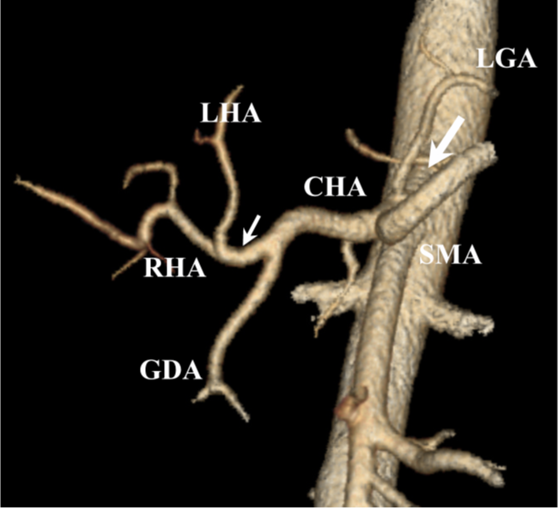
Figure 1. Classic anatomy of celiac and hepatic arteries. CTA arterial phase, VR reformation. LGA – left gastric artery, celiac artery – large white arrow, SMA – superior mesenteric artery, CHA – common hepatic artery, proper hepatic artery – small white arrow, LHA – left hepatic artery, RHA – right hepatic artery, GDA – gastroduodenal artery.

Table 4. Celiac artery anatomical variants
Description | Percentage | No. of patients
Classic CA trifurcation (common trunk of LGA, CHA and SA) | 81.9 | 72
Replaced CHA arising from SMA, (gastrolienal trunk; included variant with ambiguous CA anatomy and persistent intrahepatic anastomotic channel) (Song SY et al., 2010) | 6.8 (1.1) | 6 (1)
Replaced CHA arising from aorta, (gastrolienal trunk) | 1.1 | 1
LGA arising from aorta (hepatolienal trunk) | 3.4 | 3
RHA arising from CA (double hepatic artery) (Fasel JH et al., 1996) | 3.4 | 3
GDA arising from CA (absent CHA, ambiguous CA anatomy) (Song SY et al., 2010) | 1.1 | 1
Celiacomesenteric trunk (common trunk of CA and SMA) | 2.3 | 2
Total: | 100 | 88
CA – celiac artery, LGA – left gastric artery, CHA – common hepatic artery, SA – splenic artery, SMA – superior mesenteric artery, RHA – right hepatic artery, GDA – gastroduodenal artery.

Inferior phrenic artery anatomical variants
The most common origins of the inferior phrenic arteries were aorta (n=57) and celiac artery (n=41). They aroused from right renal (n=4) and left gastric arteries (n=1) with less frequency. Right and left inferior phrenic arteries branched from common trunk in 43.2% (n=38) of cases (Tables 5 and 6).

Table 5. Sites of inferior phrenic arteries origin and frequencies
 | CA only | Aorta only | CA and aorta | Other arteries* | Total
No. of Patients | 26 | 42 | 15 | 5 | 88
Percentage | 29.5 | 47.7 | 17.1 | 5.7 | 100
Other arteries* - right renal artery (n=4), left gastric artery (n=1).

Table 6. Sites of paired and unpaired (common trunk) inferior phrenic arteries origin and frequencies
 | CA | Aorta | Other arteries* | No. of Patients
Right inferior phrenic artery | 6 | 9 | 5 | 20
Left inferior phrenic artery | 10 | 10 | 0 | 20
Right and left inferior phrenic arteries | 12 | 18 | 0 | 30
Common trunk of inferior phrenic artery | 14 | 24 | 0 | 38
Total: |  |  |  | 88
Other arteries* - right renal artery (n=4), left gastric artery (n=1).

Hepatic artery anatomical variants
Accordingly to Michels’ classification, 48.9% (n=43) of patients had classic hepatic arterial anatomy (type I; Figure 1). The most common anatomical variants were Michels’ types II, III, and IX (5.7%, n=5). Results are presented in Table 7.
The most common origins of aberrant hepatic arteries were SMA and LGA. 20.5% (n=18) of studied patients had aberrant hepatic artery arising from SMA: replaced RHA in 9 cases, accessory RHA in 3 cases, replaced CHA in 6 cases (Figures 2 and 3). 21.6% (n=19) of patients had aberrant hepatic artery arising from LGA: replaced LHA in 13 cases, accessory LHA in 6 cases.

Table 7. Hepatic arterial anatomical variants according to Michels’ classification
Type | Description | Percentage | No. of Patients
I | Classic anatomy | 48.9 | 43
II | Replaced LHA arising from LGA | 5.7 | 5
III | Replaced RHA arising from SMA | 5.7 | 5
IV | Replaced LHA and replaced RHA | 4.5 | 4
V | Accessory LHA arising from LGA | 1.1 | 1
VI | Accessory RHA arising from SMA | 1.1 | 1
VII | Accessory LHA and accessory RHA | 0 | 0
VIII | Replaced LHA and accessory RHA or accessory LHA and replaced RHA | 1.1 | 1
IX | Replaced CHA arising from SMA | 5.7 | 5
X | Replaced CHA arising from LGA | 0 | 0
XI | Any variant not included in Michels’ classification | 26.2 | 23
Total: |  | 100 | 88
LHA – left hepatic artery, LGA – left gastric artery, RHA – right hepatic artery, SMA – superior mesenteric artery, CHA – common hepatic artery.
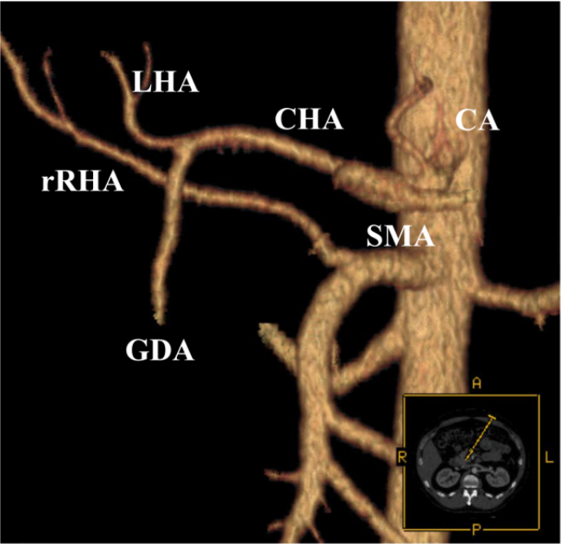
Figure 2. Replaced right hepatic artery arising from superior mesenteric artery (type III according to Michels’ classification). CTA arterial phase, VR reformation. CA - celiac artery, SMA – superior mesenteric artery, GDA – gastroduodenal artery, rRHA – replaced right hepatic artery, LHA – left hepatic artery, CHA – common hepatic artery.

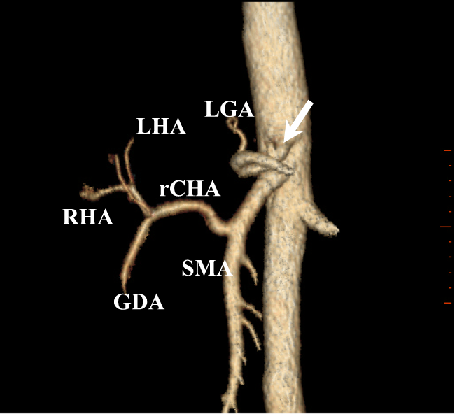
Figure 3. Replaced common hepatic artery arising from superior mesenteric artery (type IX according to Michels’ classification). CTA arterial phase, VR reformation. Celiac artery - white arrow, SMA – superior mesenteric artery, rCHA – replaced common hepatic artery, GDA – gastroduodenal artery, RHA – right hepatic artery, LHA – left hepatic artery, LGA – left gastric artery.
Hepatic arterial variants not classified by Michels’ classification were observed in 26.2% (n=23) of cases (Table 8). The most common variant was CHA trifurcation into GDA, RHA, and LHA (n=6).
Table 8. Hepatic arterial variants not classified by Michels’ classification
Anatomical variations | No. of Patients
CHA trifurcation into GDA, RHA, and LHA | 6
CHA trifurcation into GDA, RHA, and LHA, accessory LHA arising from LGA | 1
CHA trifurcation into GDA, RHA, and LHA, accessory RHA arising from SMA | 1
CHA trifurcation into PHA, accessory RHA, and GDA | 1
CHA quadrifurcation into LHA, RHA, accessory RHA, and GDA | 1
Replaced CHA arising from aorta, GDA arising from RHA | 1
LGA arising from aorta, accessory LHA arising from LGA, accessory RHA arising from GDA | 1
LGA arising from aorta, replaced LHA arising from LGA | 1
LGA arising from aorta | 1
Accessory LHA arising from LGA, accessory RHA arising from CA | 1
Accessory LHA arising from LGA, RHA and accessory RHA arising from GDA | 1
Accessory LHA arising from LGA, accessory RHA arising from GDA | 1
Replaced LHA arising from LGA, accessory RHA arising from CA | 1
RHA arising from CA | 1
GDA arising from CA (absent CHA, ambiguous anatomy) (Song SY et al., 2010) | 1
Variant with persistent intrahepatic anastomotic channel (ambiguous anatomy) (Song SY et al., 2010) | 1
Celiacomesenteric trunk (common trunk of CA and SMA) | 2
Total: | 23
CA – celiac artery, SMA – superior mesenteric artery, LGA – left gastric artery, CHA – common hepatic artery, PHA – proper hepatic artery, LHA – left hepatic artery, RHA – right hepatic artery, GDA – gastroduodenal artery.

Diameters of hepatic arteries
All accessory LHA, 77% of replaced LHA, and 73.3% of LHA diameters were ≤3 mm. The number of such narrow arteries was smaller among right hepatic lobe feeding arteries: 70% of accessory RHA, 22.2% of replaced RHA and 50.6% of RHA.
Only 10.3% of PHA and 2.5% of CHA had 3 mm or lesser diameter. The results are presented in Table 9.
Table 9. Hepatic arteries with diameter ≤3 mm
Hepatic arteries | No. of arteries | No. of arteries with diameter ≤3 mm | Percentage
CHA | 80 | 2 | 2.5
Replaced CHA | 7 | 0 | 0
PHA | 58 | 6 | 10.3
RHA | 79 | 40 | 50.6
Replaced RHA | 9 | 2 | 22.2
Accessory RHA | 10 | 7 | 70
LHA | 75 | 55 | 73.3
Replaced LHA | 13 | 10 | 77
Accessory LHA | 6 | 6 | 100
CHA – common hepatic artery, PHA – proper hepatic artery, RHA – right hepatic artery, LHA – left hepatic artery.

Changes of superior mesenteric artery hemodynamics caused by aberrant hepatic artery branching from superior mesenteric artery
DUS was diagnostic in 64 of 67 patients. Three patients were excluded because of interposed intestinal gas. Those 64 patients were divided into two groups. Patients (n=17) with aberrant hepatic artery arising from SMA referred to group 1. Five of them had replaced CHA, nine - replaced RHA, and three - accessory RHA. Group 2 (n=47) consisted of 43 patients with classic hepatic artery anatomy and four patients with classic hepatic artery anatomy variant - CHA trifurcation into GDA, RHA, and LHA.
Mean diameter value of aberrant hepatic arteries arising from SMA (n=17) was 4.4 ± 1.5 mm (range, 2.3 – 8 mm). The mean distance from the SMA aortic orifice to the aberrant hepatic arteries was 24.2 ± 13.6 mm (range, 9 – 71 mm). 16 patients had these vessels arising within first 3 cm from the origin of SMA and only one patient had aberrant hepatic artery that branched 7 cm from SMA origin. Summary of SMA diameters is presented in Table 10.
Table 10. Superior mesenteric artery diameters
 | All patients  (n=64) | Group 1  (n=17) | Group 2  (n=47) | P value
Mean SMA diameters ± SD mm  (range) | 6,9 ± 1,5  (3,7 – 10,5) | 7,5 ±1,3  (5,4 – 9,5) | 6,7 ± 1,5  (3,7 – 10,5) | P=0,046
SMA - superior mesenteric artery, SD – standard deviation.
A corrected RI equation was used in seven patients with heart rates above 80 beats per minute. Mean SMA RI value of all patients (n=64) was 0.85 ± 0.05 (range, 0.75-0.93).
Multivariable linear regression analysis (n=64) determined which of the factors (age, sex, essential hypertension, anatomic variants of hepatic artery – aberrant hepatic artery arising from SMA/classic hepatic arterial anatomy and variant with CHA trifurcation into GDA, RHA and LHA) was significantly associated with SMA RI value. Only an anatomical variant with aberrant hepatic artery arising from SMA was statistically significantly and inversely associated with SMA RI value (β= -0,42; P=0,001; Table 11).

Table 11. Multivariable linear regression for associations between age, sex, essential hypertension, anatomic variants of hepatic artery and superior mesenteric artery RI value
Variable | Linear regression coefficient β | P value
Age | 0.02 | 0.84
Sex (male vs female) | 0.06 | 0.64
Essential hypertension (yes vs no) | 0.04 | 0.75
Aberrant hepatic artery arising from SMA (yes vs no) | -0.42 | 0.001
SMA – superior mesenteric artery.

The characteristic Doppler waveform of the SMA and Doppler waveform of the SMA with an aberrant hepatic artery arising from the SMA are presented on Figures 4 and 5 respectively.

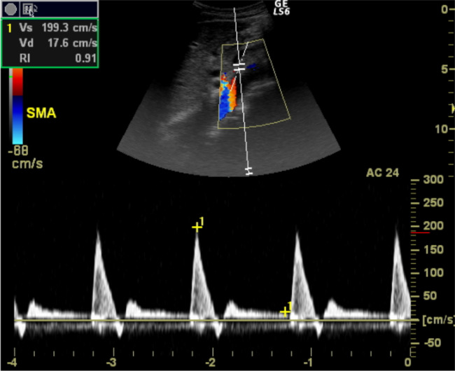
Figure 4. Duplex (Triplex) ultrasound of superior mesenteric artery (classic anatomy of hepatic arteries). Typical triphasic high-resistance Doppler spectrum of superior mesenteric artery in fasting condition.

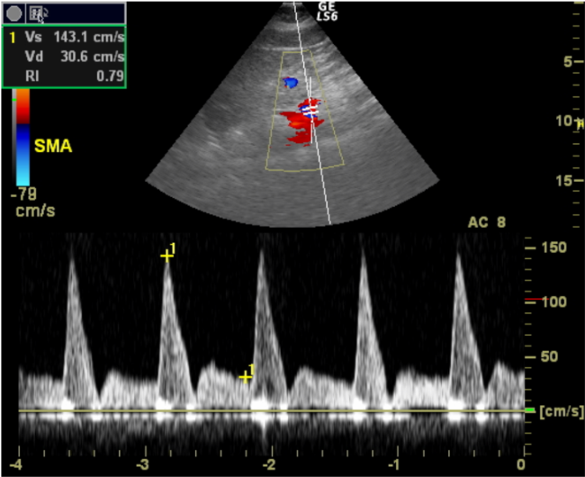
Figure 5. Duplex (Triplex) ultrasound of superior mesenteric artery with aberrant hepatic artery arising from superior mesenteric artery. Postsystolic reversal flow is absent, large diastolic flow component is observed (fasting condition).

Mean RI value in group 1 (0.81 ± 0.05; range 0.75-0.91) was statistically significantly lower (P=0.0003) than in group 2 (0.86 ± 0.04; range, 0.77-0.93). Despite the clear evidence of statistically significant differences of SMA RI values, they overlap to large extent (Figure 6).
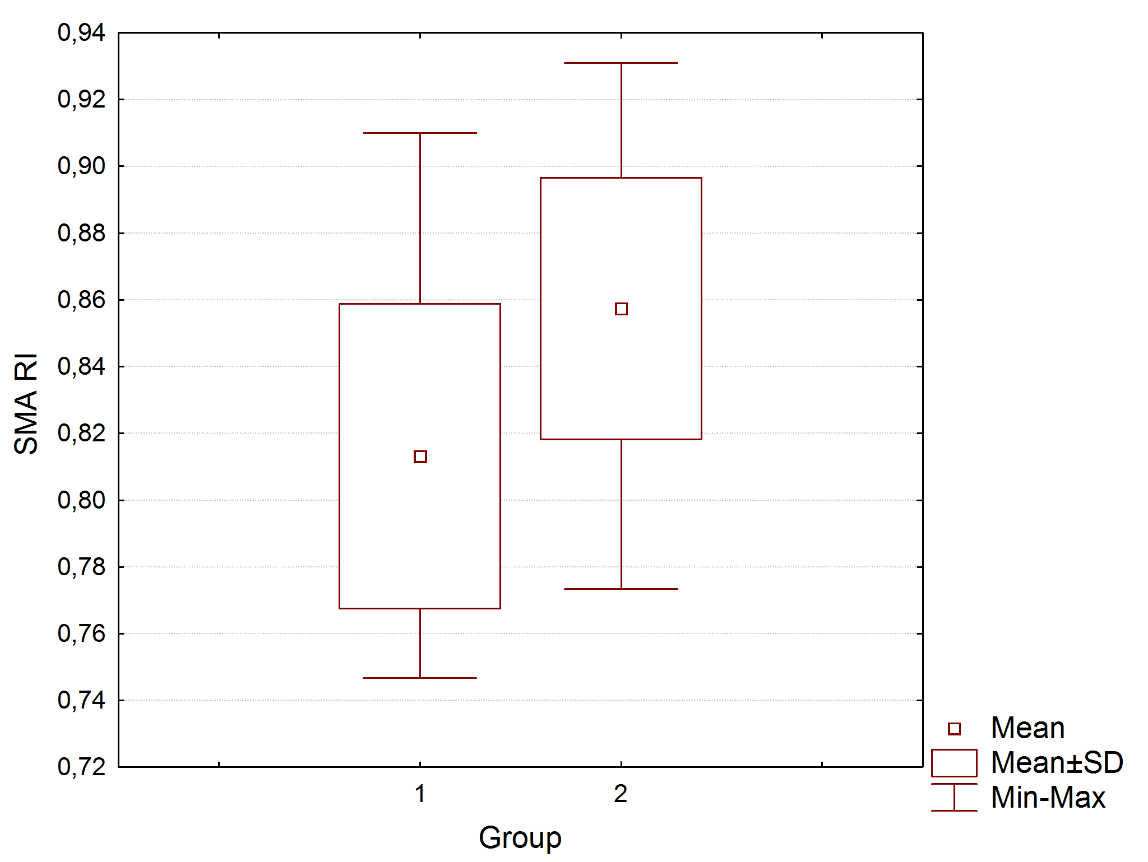
Figure 6. Box-and-whisker diagram represents marked overlap of absolute SMA RI values between group 1 and group 2. SMA - superior mesenteric artery, RI – resistive index, SD – standard deviation.

CONCLUSIONS

- Superior mesenteric artery resistance is lower if aberrant hepatic artery branches from it.
- Celiac artery, inferior phrenic and hepatic artery anatomical variants are frequent. Aberrant hepatic arteries usually arise from left gastric or superior mesenteric arteries.
- Small caliber extrahepatic hepatic arteries (≤3 mm) usually are typically branching right and left lobar hepatic arteries, accessory hepatic arteries and left replaced hepatic arteries.

PRACTICAL RECOMMENDATIONS

- Patients with aberrant hepatic artery arising from superior mesenteric artery should be included into separate group in clinical studies evaluating hemodynamics of the superior mesenteric artery.
- Splanchnic arterial anatomy variants are frequent and it is important to evaluate them before surgical operations or minimally invasive procedures.

LIST OF PUBLICATIONS
- Samuilis A, Strupas A, Tamošiūnas AE. Computed tomography angiography in the evaluation of the celiac and hepatic artery anatomical variants. Theory and Practice in Medicine 2011 (accepted for publication);
- Paškonis M, Mašalaitė L, Buivydienė A, Sokolovas V, Jurgaitis J, Jurevičius S, Mikalauskas S, Gutauskas M, Špūras J, Šarkaite R, Samuilis A, Rutkauskaitė D, Misionis N, Dukštaitė A, Šerpytis M, Kėkštas G, Rainienė T, Barakauskienė A, Valantinas J, Strupas K. Orthotopic liver transplantation: the first experience and results of the Vilnius University Hospital Santariskiu Klinikos. Ann Transplant. 2010 Mar 19;15(1):14-24;
- Samuilis A, Sejonienė J, Tamošiūnas AE. Anatomic variations of portosystemic collaterals in patients with liver cirrhosis. Theory and Practice in Medicine 2009; 15 (3): 293–297;
- Jurgaitis J, Paškonis M, Pivoriūnas J, Martinaitytė I, Juška A, Jurgaitienė R, Samuilis A, Volf I, Schöbinger M, Schemmer P, Kraus TW, Strupas K. The comparison of 2-dimensional with 3-dimensional hepatic visualization in the clinical hepatic anatomy education. Medicina (Kaunas) 2008; 44 (6): 428-438;
- Jurgaitis J, Paškonis M, Samuilis A, Volf I, Schöbinger M, Brimas G, Strupas K. Three-dimensional visualization: applications in liver surgery. Lithuanian Surgery. – 2006 4 (4), 283-291;
- Tamošiūnas A, Valantinas J, Samuilis A. Evaluation of the patients after and before surgical operations. In: Doppler ultrasound diagnostics 2004: educational book. Vilnius 2004; 235-238.

ABSTRACTS
- Samuilis A, Tamošiūnas AE. Influence of hepatic artery anatomical variants on superior mesenteric artery hemodynamics. 3rd Baltic Congress of Radiology, October 8-9, 2010, Riga, Latvia: 59;
- Samuilis A, Tamošiūnas AE. Influence of anatomical variants of abdominal aortic branches on visceral hemodynamics. 3rd National Scientific Conference Science for Health of People, April 7, 2010, Kaunas, Lithuania: 49;
- Sejonienė J., Samuilis A. Iodinated contrast media in imaging: adverse reactions and prophylaxis. The competence of clinicians. Scientific Practical Conference Gastroenterology 2009, December 4-5, 2009, Trakai, Lithuania: 48-49.

PRESENTATIONS
- Samuilis A, Tamošiūnas AE. Influence of hepatic artery anatomical variants on superior mesenteric artery hemodynamics. 3rd Baltic Congress of Radiology, October 8-9, 2010, Riga, Latvia (Poster);
- Sejonienė J, Samuilis A. Iodinated contrast media in imaging: adverse reactions and prophylaxis. The competence of clinicians. Scientific Practical Conference Gastroenterology 2009, December 4-5, 2009, Trakai, Lithuania: 48-49 (Oral presentation);
- Samuilis A., Tamošiūnas AE. Anatomical variants of visceral branches of abdominal aorta. XVII Scientific Conference of Lithuanian Association of Radiology, October 16-17, 2009, Panevėžys, Lithuania (Oral presentation).

BRIEF INFORMATION ABOUT THE AUTHOR
Artūras Samuilis was born on December 5, 1976 in Vilnius, Lithuania. After finishing Vilnius Užupio high school he studied at the Medical Faculty of Vilnius University. He obtained the Diploma of Medical Doctor in 2001. He started his residence of radiology at the Medical Faculty of Vilnius University after one-year internship. Artūras Samuilis obtained the license of radiologist in 2006 and started to work at Vilnius University Hospital Santariškių klinikos as a radiologist. He had a traineeship at the Department of Radiology of University of Heidelberg (Germany) in the same year. From 2006 until 2010 he maintained the doctor’s thesis at the Vilnius University Faculty of Medicine. The main field of his scientific interest was anatomical variants of hepatic arteries and their influence on mesenteric hemodynamics. From 2006 Artūras Samuilis is an active member of Lithuanian Association of Radiology. He is a member of European Society of Radiology also. The author is interested in the field of abdominal radiology. Six articles of A. Samuilis with co-authors were published in reviewed Lithuanian and International scientific journals.

REZIUMĖ

Santrumpos

Santrumpa | Santrumpos paaiškinimas
BA | blužnies arterija
BKA | bendroji kepenų arterija
DKA | dešinioji kepenų arterija
DUG | doplerio ultragarsas
KKA | kairioji kepenų arterija
KSA | kairioji skrandžio arterija
KTA | kompiuterinės tomografijos angiografija
PK | pilvinis kamienas
RI | rezistentiškumo indeksas
SD | standartinis nuokrypis
SDA | skrandžio ir dvylikapirštės žarnos arterija
SKA | savoji kepenų arterija
VPA | viršutinė pasaito arterija

Įvadas

Yra žinoma, kad klasikinė pilvinio kamieno anatomija pasitaiko 75– 90 proc., kepenų arterijų - 50–81 proc. asmenų. Klasikiniu atveju pilvinis kamienas (PK; truncus celiacus) atsišakoja iš aortos nepriklausomai nuo viršutinės pasaito arterijos (VPA; a. mesenterica superior). Jis šakojasi į kairiąją skrandžio arteriją (KSA; a. gastrica sinistra), bendrąją kepenų arteriją (BKA; a. hepatica communis) bei blužnies arteriją (BA; a. lienalis). Šios kraujagyslės yra laikomos pagrindinėmis PK šakomis. BKA šakojasi į savąją (tikrąją) kepenų (SKA; a. hepatica propria), skrandžio ir dvylikapirštės žarnos (SDA; a. gastroduodenalis) arterijas. Kepenų vartuose iš SKA atsišakoja dešinioji (DKA; a. hepatica dextra) bei kairioji kepenų arterijos (KKA; a. hepatica sinistra).
Arterijos, kurios atsišakoja netipiškai, vadinamos aberantinėmis. Jos klasifikuojamos į pridėtines, kada kepenų skiltis gauna papildomą arterinę kraujotaką, bei perkeltąsias, kada kepenų skiltis maitinama vienintelės arterijos, atsišakojančios ne iš PK.
Dažniausiai aberantinės kepenų arterijos atsišakoja iš VPA ir KSA: iš VPA atsišakojančios šios kraujagyslės, įvairių literatūros šaltinių duomenimis, pasitaiko 8–27 proc. asmenų, iš KSA – 4–34 proc. atvejų.
PK ir kepenų arterijų anatominiai variantai yra svarbūs planuojant kepenų ir tulžies latakų (įskaitant kepenų transplantaciją), skrandžio, kasos ir dvylikapirštės žarnos operacijas ar intervencines radiologines procedūras, tokias kaip infuzinė chemoterapija, intraarterinė chemoembolizacija. Anatominiai variantai gali būti nustatyti prieš operaciją radiologiniais tyrimais ar operacijos metu. Kita vertus, operacijos metu gali būti keblu įvertinti kepenų arterijų anatomiją, kai kepenų ir dvylikapirštės žarnos raištyje (lig. hepatoduodenale) yra gausu riebalinio audinio, navikas infiltruoja kepenų vartus, esant limfadenopatijai, fibroziniams pakitimams po buvusių uždegimų ar operacijų. Tokiais atvejais priešoperacinis kepenų arterijų anatomijos įvertinimas gali palengvinti operacijos eigą ir sumažinti pooperacinių komplikacijų (kraujavimo, kepenų išemijos ar nepakankamumo, biliarinių striktūrų, bilomų) skaičių. Netikslus kepenų arterijų anatominių variantų įvertinimas prieš skiriant kepenų arterinę infuzinę chemoterapiją ar chemoembolizaciją gali sukelti virškinimo trakto uždegiminius pakitimus, išopėjimus, sąlygoti nevisavertį navikinio proceso kepenyse gydymą ar arterijos okliuziją.
Planuojant kepenų, ypač gyvo donoro, transplantacijas vien tik įvertinti arterijų anatominius variantus nepakanka. Šiuo atveju yra svarbus kepenų arterijų diametras. Atliekant šias operacijas mažo diametro (≤3 mm) kepenų arterijos laikomos rizikos faktoriumi susiformuoti arterinei trombozei. Vadinasi, siekiant išvengti galimų komplikacijų esant mažo diametro kepenų arterijoms gali tekti keisti chirurginę gydymo taktiką ar apskritai atsisakyti operacijos.
Apatinės diafragminės arterijos yra vienas iš kepenų kolateralinės kraujotakos šaltinių. Jos dažnai maitina hepatoceliulinės karcinomos židinius, kurie lokalizuojasi pilvaplėve nepadengtuose su diafragma besiliečiančiuose kepenų segmentuose (I,II,VII). Tokiu būdu jos gali turėti įtakos chemoembolizacijos per arteriją efektyvumui. Apatinės diafragminės arterijos taip pat gali būti kraujavimo iš kvėpavimo takų ar plaučių, potrauminių ar dėl gydymo atsiradusių pakraujavimų iš diafragmos ar kepenų priežastimi. Jos panašiu dažniu paprastai atsišakoja iš aortos ar PK. Skiriamos dešinioji ir kairioji ar bendroji apatinės diafragmos arterijos.
Taigi, visceralinių arterijų anatominių variantų įvertinimas prieš operacijas ar minimaliai intervencines procedūras gali palengvinti operacijos ar intervencinės procedūros eigą ir sumažinti galimų komplikacijų skaičių. Minėtų arterijų anatominiai variantai gali būti įvertinti pasitelkus šiuos radiologinius tyrimo metodus: ultragarsinį tyrimą panaudojant doplerio režimą (DUG) ar jo nenaudojant, kompiuterinės tomografijos angiografiją (KTA), magnetinio rezonanso angiografiją ar konvencinę angiografiją.
Šiuo metu pagrindiniai neinvaziniai tyrimo metodai, kurių pagalba galima įvertinti visceralinių arterijų anatomiją, yra KTA ir magnetinio rezonanso angiografija. Jie išstūmė į antrą planą auksiniu standartu laikomą konvencinę angiografiją, kadangi leidžia įvertinti ne tik kraujagyslių spindžius, bet ir jų sieneles, santykį su aplinkinėmis struktūromis, vidaus organus vieno tyrimo metu.
Vienas didžiausių DUG tyrimo privalumų yra tas, kad jis suteikia ne tik anatominės, bet ir funkcinės informacijos. Šiuo metu tai vienas populiariausių in vivo tyrimo metodų vertinant virškinimo sistemos organų kraujagyslių hemodinamiką (hemodinamika – tai mokslo sritis, nagrinėjanti kraujotakos fizikinius procesus, įskaitant širdies funkcines bei periferinių kraujagyslių fiziologines charakteristikas). Tai pigus, neinvazinis, tikslus, atkartojamas, nesukeliantis apšvitos tyrimas. DUG plačiai naudojamas vertinant VPA hemodinamiką esant įvairioms fiziologinėms būklėms, sąlygotoms: amžiaus, fizinio krūvio, maisto įtakos. DUG taikomas tiriant medikamentų poveikį ir gydymo efektą, hemodinamikos pokyčius po operacijų. Taip pat šiuo metodu gali būti įvertinta kraujotaka VPA esant įvairioms patologinėms būklėms ar ligoms, tokioms kaip: ūminė ar lėtinė žarnų išemija, gliuteninė enteropatija bei uždegiminės žarnų ligos, lėtinės kepenų ligos, pirminė arterinė hipertenzija, ūminiai ir lėtiniai pankreatitai bei kitos ligos ar būklės.
Literatūroje aprašyti pavieniai atvejai apie iš VPA atsišakojančios aberantinės kepenų arterijos įtaką VPA hemodinamikai. Vienas žymiausių tyrimų 1998 m. atliktas R. M. Zwolak su kolegomis (n=46) (Zwolak RM ir kt., 1998). DUG radiniai lyginti su konvencinės angiografijos duomenimis. Angiografiškai buvo aptikti šie PK ir kepenų arterijų anatominiai variantai: viena perkeltoji DKA, atsišakojanti iš VPA, po vieną perkeltąją BKA, atsišakojančią iš VPA ir aortos, vienas bendras PK ir VPA kamienas. Trys iš keturių anatominių variantų buvo teisingai nustatyti DUG: perkeltoji DKA, atsišakojanti iš VPA, perkeltoji BKA, atsišakojanti iš VPA ir bendras PK ir VPA kamienas. Pirmieji du variantai buvo teisingai nustatyti remiantis VPA registruota netipine žemo rezistentiškumo dvifaze, o ne įprasta trifaze doplerio banga. Be to, buvo matoma stambi VPA šaka, einanti link kepenų. Tokius kraujotakos pokyčius galima paaiškinti tuo, kad, kitaip nei VPA, kepenų arterijoms kaip ir PK būdinga žemo rezistentiškumo dvifazė kraujotaka esant pastoviai kraujotakai diastolės metu. Tuo tarpu nevalgiusio paciento VPA būdinga trifazė aukšto rezistentiškumo kraujotaka: po sistolinio piko diastolės pradžioje būdinga reversinė kraujotaka, kuri diastolės viduryje vėl pagreitėja (antegradinė) bei palaipsniui lėtėja ir prieš pat sistolę išnyksta.
Taigi, tyrėjas, nesusipažinęs su aukščiau apibūdintu VPA anatominiu variantu, padidėjusią diastolinę kraujotaką bei sumažėjusį kraujotakos rezistentiškumą VPA, dėl joje atsišakojančios žemo rezistentiškumo kepenų arterijos įtakos, gali klaidingai interpretuoti kaip potencialią patologiją: VPA stenozę, uždegiminę žarnų ligą, kepenų cirozę, lėtinį pankreatitą, neoplazinį procesą virškinimo sistemos organuose, smulkių pasaito arterijų okliuziją. Reiktų pridurti, kad dėl maisto, kai kurių vaistų poveikio rezistentiškumas VPA taip pat mažėja.
Todėl mums iškilo klausimas: kaip reikšmingai aberantinė kepenų arterija, atsišakojanti iš VPA, veikia VPA hemodinamiką.

Tyrimo tikslas

Nustatyti iš viršutinės pasaito arterijos atsišakojančių aberantinių kepenų arterijų anatominius variantus ir jų įtaką viršutinės pasaito arterijos hemodinamikai (rezistentiškumui).

Tyrimo uždaviniai

- Doplerio ultragarso metodu nustatyti viršutinės pasaito arterijos rezistentiškumo priklausomybę nuo joje atsišakojančios aberantinės kepenų arterijos.
- Kompiuterinės tomografijos angiografijos metodu įvertinti pilvinio kamieno, apatinių diafragminių ir kepenų arterijų anatominius variantus.
- Kompiuterinės tomografijos angiografijos metodu įvertinti smulkaus diametro (≤3 mm) ekstrahepatinių kepenų arterijų paplitimo dažnį.

Darbo naujumas

Nors yra pastebėta, kad iš VPA atsišakojanti aberantinė kepenų arterija daro įtaka VPA hemodinamikai, didesnės apimties įrodymais pagrįstų tyrimų, mūsų žiniomis, nebuvo atlikta. Vienintelis išsamesnis tyrimas pritaikant DUG buvo atliktas R.M. Zwolak ir kolegų (n=46) (Zwolak RM ir kt., 1998). Autoriai šiuo tyrimu teisingai nustatė 3 iš 4 visceralinių arterijų netipinius anatominius variantus, kurie buvo patvirtinti angiografijos metodu. Dviems pacientams, kuriems iš VPA atsišakojo aberantinės kepenų arterijos, VPA registruota netipinė žemo rezistentiškumo dvifazė, o ne įprasta trifazė doplerio banga. Taigi, lieka neaišku, ar aberantinės kepenų arterijos, atsišakojančios iš VPA, įtaka VPA hemodinamikai yra reikšminga.

Ginamieji teiginiai

- Kepenų arterijų anatominiai variantai yra dažni. Aberantinės kepenų arterijos dažniausiai atsišakoja iš kairiosios skrandžio bei viršutinės pasaito arterijų.
- Viršutinės pasaito arterijos rezistentiškumas pakinta, jeigu iš jos atsišakoja aberantinė kepenų arterija.

Tyrimo medžiaga ir metodai

Tiriamoji medžiaga rinkta nuo 2009 metų vasario iki 2010 sausio mėnesių VšĮ Vilniaus universiteto ligoninės Santariškių klinikos Radiologijos ir branduolinės medicinos centre. Vilniaus regioninis bioetikos komitetas išdavė leidimą atlikti šį perspektyvinį tyrimą, į kurį buvo įtraukti tik pasirašę informuoto asmens sutikimo formą suaugę asmenys. Jiems dėl įvairių klinikinių indikacijų buvo kokybiškai gerai atlikta KTA (kontrastiškumas aortoje PK lygyje ne mažesnis kaip 200 Hounsfield vienetų; galimybė įvertinti bent pirmos eilės intrahepatines kepenų arterijas). Neįtraukimo į tyrimą kriterijai: sunki bendra paciento būklė, virškinimo sistemos organų ligos (uždegiminės, navikinės, kepenų cirozė), vertinamų arterijų hemodinamiškai reikšmingos stenozės (>50 proc.), arterijų aneurizmos ir įgimtos kraujagyslinės anomalijos. Į tyrimą taip pat neįtraukti asmenys ankstyvuoju pooperaciniu periodu (iki 1 mėn.), taip pat tie, kuriems buvo atliktos tiriamųjų kraujagyslių bei didelės apimties virškinimo sistemos organų operacijos, nėščios moterys bei pažeidžiami asmenys. Tiems atrinktiems pacientams, kuriems buvo atliekami VPA kraujotakos tyrimai, atmetimo kriterijumi laikytas neinformatyvus DUG (pvz., blogas akustinis langas dėl gausių dujų virškinimo trakte).
Iš viso į tyrimą įtraukti 88 suaugę asmenys, kuriems dėl įvairių klinikinių priežasčių buvo kokybiškai gerai atlikta KTA. KTA metodu įvertinta pilvo organų, aortos ir jos visceralinių šakų būklė, PK, apatinių diafragminių ir kepenų arterijų anatominiai variantai, pamatuoti kepenų arterijų ir VPA diametrai. Kepenų arterijų anatominiai variantai suklasifikuoti pagal N. A. Michels klasifikaciją (Michels N.A., 1966).
Norint įvertinti aberantinės kepenų arterijos, atsišakojančios iš VPA, įtaką VPA hemodinamikai (rezistentiškumui), buvo atliktas DUG. Šiam tyrimui iš minėtų 88 tiriamųjų buvo atrinkti 67 pacientai, kurių kepenų arterijų anatomija buvo nustatyta KTA. Vienų atrinktų asmenų kepenų arterijų šakojimosi anatomija buvo klasikinė (įskaitant jos variaciją - BKA trifurkaciją į SDA, DKA ir KKA), o kiti turėjo aberantinę kepenų arteriją, atsišakojančią iš VPA. DUG būdu buvo atlikta detali proksimalinio VPA segmento kraujotakos analizė. VPA rezistentiškumui įvertinti buvo pasirinktas rezistentiškumo indeksas (RI) (Pourcelot L, 1976).
Iš 67 tinkamų atlikti DUG kandidatų, trims pacientams dėl gausaus dujų kiekio virškinimo trakte tyrimas buvo neinformatyvus. Norint įvertinti aberantinės kepenų arterijos, atsišakojančios iš VPA, įtaką VPA rezistentiškumui, likę 64 pacientai sugrupuoti į dvi grupes: į 1-ąją grupę įtraukta 17 tiriamųjų, turinčių aberantinę kepenų arteriją, atsišakojančią iš VPA, į 2-ąją – 47 pacientai, kurių kepenų arterijų anatomija buvo klasikinė (keturiems iš jų buvo būdinga klasikinės anatomijos variacija – BKA trifurkacija į SDA, DKA ir KKA).

Rezultatai
Statistinė analizė buvo atlikta SPSS 17.0 programinės įrangos paketu (SPSS Inc., Chicago, IL). Pacientų amžius, VPA ir kepenų arterijų diametrai, atstumas nuo žiočių aortoje iki aberantinės kepenų arterijos atsišakojimo iš VPA, VPA RI vertė pateikti kaip aritmetinis vidurkis ± standartinis nuokrypis (SD). Normaliniam pasiskirstymui įvertinti buvo atlikti Kolmogorov-Smirnov ar Shapiro-Wilk (n<50) testai. Atskirų parametrų skirtumų tarp lyginamų grupių reikšmingumas buvo vertintas vieno faktoriaus dispersinės analizės testu (angl. one-way ANOVA testing). Priklausomybė tarp VPA RI ir amžiaus, lyties, pirminės arterinės hipertenzijos bei kepenų arterijų anatominių variantų (aberantinės kepenų arterijos, atsišakojančios iš viršutinės pasaito arterijos/klasikinės kepenų arterijų anatomijos bei jos variacijos – BKA trifurkacijos į SDA, DKA ir KKA) įvertinta daugialypės tiesinės regresijos metodu (angl. multiple linear regression). Buvo atlikti modelio tinkamumo ir kolineariškumo testai. Skirtumai vertinti kaip statistiškai patikimi, jei P reikšmė <0,05.
88 pacientų, įtrauktų į šį tyrimą, amžiaus vidurkis 47,6 ± 12,4 metai (intervalas, 19 – 79 metai). Iš jų 62,5 proc. (n=55) buvo moterys, kurių amžiaus vidurkis 47,4 ± 12,5 metai (intervalas, 19 – 79 metai). Vyrai sudarė 37,5 proc. (n=33), jų amžiaus vidurkis 48,1 ± 12,4 metai (intervalas, 19 – 67 metai). Apie pusę pacientų sirgo pirmine arterine hipertenzija – 51,1 proc. (n=45).
Asmenų, kuriems kokybiškai buvo atliktas DUG (n=64), amžiaus vidurkis 48,4 ± 12,2 metai (intervalas, 19 – 79 metai). Moterys sudarė 62,5 proc. (n=40), vyrai – 37,5 proc. (n=24). 1-osios grupės tiriamųjų (turinčių aberantinę kepenų arteriją, atsišakojančią iš VPA) amžiaus vidurkis 47,6 ± 12,3 metai (intervalas, 19 – 65 metai) iš jų moterys sudarė 76,5 proc. (n=13). 2-osios grupės (klasikinė kepenų arterijų anatomija ir jos variacija - BKA trifurkacija į SDA, DKA ir KKA) tiriamųjų amžiaus vidurkis 48,7 ± 12,3 metai (intervalas, 19 – 79 metai), moterys sudarė 57,4 proc. (n=27). Pirmine arterine hipertenzija sirgo 48,4 proc. asmenų (n=31). 1-joje grupėje tokių pacientų buvo 35,3 proc. (n=6), 2-joje – 53,2 proc. (n=25).
Pagrindinėmis tipinio PK kamieno šakomis laikytos: BKA, KSA ir BA, o VPA atsišakoja nepriklausomai iš aortos. Tokia anatomija, neatsižvelgiant į diafragminių arterijų šakojimosi variacijas ir aberantines kepenų arterijas, atsišakojančias ne iš PK, pasitaikė 81,9 proc. (n=72) asmenų. Pats dažniausias PK anatominis variantas buvo bendras BA ir KSA kamienas (tr. gastrolienalis). Šiuo atveju 6,8 proc. tiriamųjų (n=6) perkeltoji BKA atsišakojo iš VPA, suformuodama bendrą kamieną (tr. hepatomesentericus). Vienam asmeniui perkeltoji BKA atsišakojo aortoje. Kitas dažniau pasitaikantis anatominis variantas buvo nepriklausomai aortoje atsišakojanti KSA (3,4 proc., n=3), tuo tarpu PK suformuoja BKA ir BA (tr. hepatolienalis). Tokiai pačiai pacientų daliai dešiniosios kepenų arterijos (skiltinės ar segmentinės) atsišakojo tiesiai iš PK. Dviems asmenims buvo bendras PK ir VPA kamienas (tr. celiacomesentericus). Vienas pacientas neturėjo BKA, iš PK tiesiogiai atsišakojo SDA.
Apatinės diafragminės arterijos atsišakojo dažniausiai iš aortos (n=57) ir PK (n=41), rečiausiai iš dešiniosios inksto arterijos (n=4) bei KSA (n=1). Tik iš aortos atsišakojo 47,7 proc. (n=42) pacientų, tik iš PK – 29,5 proc. (n=26), iš aortos ir PK – 17,1 proc. (n=15), likusios iš dešiniosios inksto arterijos ir KSA. Dešinioji bei kairioji apatinės diafragminės arterijos nustatytos 56,8 proc. (n=50) pacientų, neporinė bendroji arterija – 43,2 proc. (n=38).
Klasikinė kepenų arterijų anatomija (I tipas pagal N. A. Michels klasifikaciją) nustatyta – 48,9 proc. (n=43) tiriamųjų. Perkeltoji KKA, atsišakojanti iš KSA (II tipas), perkeltoji DKA, atsišakojanti iš VPA (III tipas), ir perkeltoji BKA, atsišakojanti iš VPA (IX tipas) pasitaikė dažniausiai – po 5,7 proc. (n=5) pacientų. Perkeltoji KKA, atsišakojanti iš KSA, ir perkeltoji DKA, atsišakojanti iš VPA (IV tipas) buvo 4,5 proc. (n=4) asmenų. Rečiausiai pasitaikė pridėtinė KKA, atsišakojanti iš KSA (V tipas), pridėtinė DKA, atsišakojanti iš VPA (VI tipas), pridėtinė arba perkeltoji KKA, atsišakojanti iš KSA, ir perkeltoji arba pridėtinė DKA, atsišakojanti iš VPA (VIII tipas) – po 1,1 proc. (n=1) pacientų. Šiame tyrime nebuvo asmenų, turinčių šiuos kepenų arterijų anatominius variantus: pridėtinė KKA, atsišakojanti iš KSA, ir pridėtinė DKA, atsišakojanti iš VPA (VII tipas), perkeltoji BKA, atsišakojanti iš KSA (X tipas).
Nesuklasifikuoti kepenų arterijų anatominiai variantai pagal N. A. Michels klasifikaciją (XI tipas) buvo 26,2 proc. (n=23) pacientų. Dažniausias jų – BKA trifurkacija į SDA, DKA ir KKA (6,8 proc., n=6), nesant kitų arterijų anomalijų.
Aberantinės kepenų arterijos dažniausiai atsišakojo iš KSA ir VPA. Iš VPA atsišakojančią kepenų arteriją turėjo 20,5 proc. tiriamųjų (n=18): perkeltoji DKA – devyni atvejai, pridėtinė DKA – trys atvejai, perkeltoji BKA – šeši atvejai. Iš KSA atsišakojanti kepenų arterija rasta 21,6 proc. pacientų (n=19): perkeltoji KKA – trylika atvejų, pridėtinė KKA- šeši atvejai.
Mažo kalibro (≤3) mm kepenų arterijos dažniausiai pasitaikė tarp kairę kepenų skiltį maitinančių arterijų: visos (n=6) pridėtinės KKA, 77 proc. (n=10) perkeltųjų KKA, 73,3 proc. (n=55) KKA. Tarp dešinę kepenų skiltį maitinančių arterijų jos pasitaikė rečiau: 70 proc. (n=7) pridėtinių DKA, 22,2 proc. (n=2) perkeltųjų DKA ir 50,6 proc. (n=40) DKA. Tokio diametro SKA buvo 10,3 proc. (n=6), BKA – 2,5 proc. (n=2).
DUG tyrimas kokybiškai gerai atliktas 64 pacientams iš 67 tinkamų. Trijų pacientų tyrimas buvo neinformatyvus dėl gausaus dujų kiekio virškinimo trakte. Į pirmąją grupę įtraukta 17 pacientų, turinčių aberantinę kepenų arteriją, atsišakojančią iš VPA. Šioje grupėje devyni pacientai turėjo perkeltąją DKA, trys pacientai pridėtinę DKA ir penki pacientai perkeltąją BKA. Antrąją grupę sudarė 47 pacientai, kurių kepenų arterijų anatomija buvo klasikinė (n=43) bei buvo jos variacija BKA trifurkacija į SDA, KKA ir DKA (n=4).
Vidutinis aberantinių kepenų arterijų, atsišakojančių iš VPA, diametras – 4,4 ± 1,5 mm (intervalas, 2,3–8 mm). Vidutinis aberantinės kepenų arterijos atsišakojimo atstumas nuo VPA žiočių aortoje – 24,2 ± 13,6 mm (intervalas, 9–71 mm). Šešiolikai pacientų šios arterijos atsišakojo pirmuose 3 cm nuo VPA atsišakojimo aortoje, tik vienam pacientui kepenų arterija atsišakojo 7 cm atstumu nuo VPA žiočių aortoje. Vidutinis VPA diametras (n=64) – 6,9 ± 1,5 mm (intervalas, 3,7-10,5 mm). VPA diametrai tarp 1-osios (vidurkis 7,5 ± 1,3 mm; intervalas, 5,4 – 9,5 mm) ir 2-osios (vidurkis 6,7 ± 1,5 mm; intervalas, 3,7 – 10,5 mm) grupių statistiškai patikimai skyrėsi (P=0,046).
Visų pacientų vidutinė VPA RI reikšmė buvo 0,85 ± 0,05 (intervalas, 0,75-0,93). Atlikus daugialypės tiesinės regresijos analizę (n=64), nustatyta, kad iš kelių galimų veiksnių (amžius, lytis, pirminė arterinė hipertenzija, aberantinė kepenų arterija, atsišakojanti iš VPA (yra/nėra)), tik anatominis variantas su aberantine kepenų arterija, atsišakojančia iš VPA, reikšmingai atvirkštine tvarka susijęs su VPA RI, t.y. RI (rezistentiškumo) mažėjimu (β= -0,42; P=0,001). RI vertė 1-joje grupėje (0,81 ± 0,05; intervalas, 0,75-0,91) buvo statistiškai patikimai mažesnė nei 2-joje grupėje (0,86 ± 0,04; intervalas, 0,77-0,93) (P=0,0003). Nepaisant statistinio patikimumo, tirtų dviejų grupių VPA RI reikšmės iš dalies sutampa.

Išvados

- Viršutinės pasaito arterijos hemodinamika yra žemesnio rezistentiškumo, jeigu iš jos atsišakoja aberantinė kepenų arterija.
- Pilvinio kamieno, apatinių diafragminių ir kepenų arterijų anatominiai variantai yra dažni. Aberantinės kepenų arterijos dažniausiai atsišakoja iš kairiosios skrandžio bei viršutinės pasaito arterijų.
- Smulkaus diametro ekstrahepatinės kepenų arterijos (≤3 mm) dažniausiai būna tipiškai atsišakojančios dešinioji bei kairioji kepenų arterijos, pridėtinės ar kairę kepenų skiltį maitinančios perkeltosios kepenų arterijos.

Praktinės rekomendacijos
- Planuojant klinikinius tyrimus, kuriais siekiama įvertinti viršutinės pasaito arterijos hemodinamiką, pacientus, turinčius aberantinę kepenų arteriją, atsišakojančią iš viršutinės pasaito arterijos, rekomenduojama išskirti į atskirą grupę.
- Visceralinių arterijų anatominiai variantai yra dažni, todėl svarbu juos įvertinti planuojant chirurgines operacijas ir minimaliai intervencines procedūras.

